# Analysis

1. **Sample Size, Population, and Reliability Checks**
   * Sample Description
     + Sample Size: The survey collected responses from 50 volunteers, representing approximately 33% of the total Sustainable Merton volunteer population (150 individuals).
     + Demographics:
       1. The dataset includes key demographic variables such as age, gender identity, and ethnic background, which allow for an assessment of diversity within the sample.
       2. Volunteers’ levels of involvement are reflected through engagement and commitment measures.
   * Representativeness
     + The sample size is moderate, covering one-third of the population, providing a snapshot of the target group. However:
     + Strength: A third of the population is significant for volunteer studies.
     + Limitations: The small sample size limits generalizability to the broader Sustainable Merton volunteer base. There may also be potential response bias, as more engaged volunteers might be overrepresented.
   * Reliability Checks
     + To calculate Cronbach’s Alpha, I used Python, leveraging statistical libraries to ensure accuracy and efficiency. First, I gathered responses for all items within each scale (e.g., Motivation, Engagement, Satisfaction) and ensured the data was properly aligned. Using the variance formula, I computed the variance for each individual item and the total variance across all items. These were then applied to the Cronbach’s Alpha formula, where is the number of items in the scale. The resulting Alpha value, 0.872, indicates high internal consistency, confirming the reliability of the scales used in the survey.
     + Cronbach’s Alpha for the scales is 0.872, indicating excellent internal consistency. This suggests that the scales used to measure Motivation, Engagement, and Satisfaction are reliable.
   * Summary of Average Scores
     + Motivation (scale: 1–7):
       1. Career: 2.83 - Relatively low, indicating less career-oriented motivation.
       2. Social: 3.58 - Moderate, reflecting some social motivations.
       3. Values: 6.02 - Very high, showing strong alignment with personal values.
       4. Understanding: 5.18 - High, suggesting volunteers seek knowledge or self-development.
       5. Enhancement: 4.31 - Moderate, reflecting some desire for self-growth.
       6. Protection: 4.14 - Moderate, showing some concern for self-protection.
     + Engagement (scale: 1–7):
       1. Vigor: 4.09 - Moderate, suggesting average energy levels in volunteering.
       2. Dedication: 5.03 - High, indicating strong emotional commitment.
       3. Absorption: 4.19 - Moderate, reflecting moderate involvement in activities.
     + Satisfaction (scale: 1–7):
       1. Task: 5.95 - Very high, showing satisfaction with the tasks performed.
       2. Organization: 5.42 - High, indicating satisfaction with Sustainable Merton’s management.
     + Commitment (scale: 1–5): 3.67 - Moderate, reflecting some intent to continue volunteering.
   * Conclusions
     + The sample is diverse enough to provide insights into the volunteer population’s motivations, engagement, and satisfaction.
     + High reliability of scales ensures robust findings.
2. **Overview of Core Constructs**

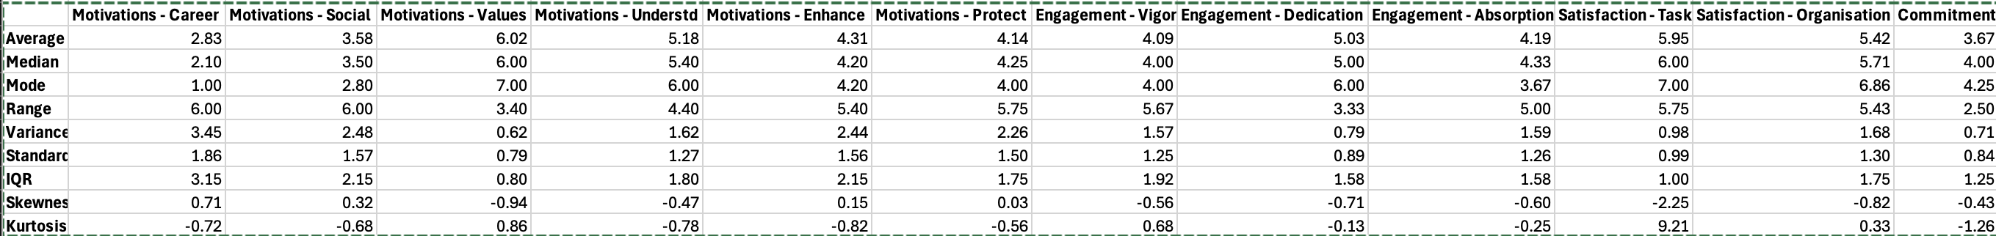

* Motivation (VFI 6 Subscales)
  + Values (Scale: 1–7)
    - Mean: 6.02
    - Standard Deviation: 0.79
    - Range: 3.40
    - Key Insight: Values motivation is the highest-rated subscale, indicating that volunteers align strongly with Sustainable Merton’s values
  + Career
    - Mean: 2.83
    - Standard Deviation: 1.86
    - Range: 6.00
    - Key Insight: Career motivation is the lowest-rated subscale, showing that career development is not a primary driver for volunteering.
  + Social
    - Mean: 3.58
    - Standard Deviation: 1.57
    - Range: 6.00
    - Key Insight: Social motivation is moderate, reflecting some importance placed on social aspects of volunteering.
  + Understanding
    - Mean: 5.18
    - Standard Deviation: 1.27
    - Range: 4.40
    - Key Insight: High understanding scores suggest that volunteers value learning and self-improvement through participation.
  + Enhancement
    - Mean: 4.31
    - Standard Deviation: 1.56
    - Range: 5.75
    - Key Insight: Volunteers moderately value personal growth and self-enhancement from their contributions.
  + Protection
    - Mean: 4.14
    - Standard Deviation: 1.50
    - Range: 5.40
    - Key Insight: Protection motivation is moderate, indicating a balance between altruistic and self-serving motives.
* Engagement (3 Subscales)
  + Vigor
    - Mean: 4.09
    - Standard Deviation: 1.57
    - Range: 5.67
    - Key Insight: Engagement in terms of vigor is moderate, suggesting volunteers are energized but not exceptionally so.
  + Dedication
    - Mean: 5.03
    - Standard Deviation: 0.79
    - Range: 3.33
    - Key Insight: Dedication is high, reflecting strong emotional involvement in volunteering activities.
  + Absorption
    - Mean: 4.19
    - Standard Deviation: 1.59
    - Range: 5.75
    - Key Insight: Moderate absorption suggests volunteers are engaged but not fully immersed.
* Satisfaction (2 Subscales)
  + Task Satisfaction
    - Mean: 5.95
    - Standard Deviation: 0.98
    - Range: 5.75
    - Key Insight: Volunteers are highly satisfied with their tasks, showing alignment between roles and expectations.
  + Organizational Satisfaction
    - Mean: 5.42
    - Standard Deviation: 1.68
    - Range: 5.43
    - Key Insight: High satisfaction with management and organizational aspects indicates effective leadership and communication.
* Commitment
  + Mean: 3.67 (Scale: 1–5)
  + Standard Deviation: 0.71
  + Range: 2.50
  + Key Insight: Moderate commitment indicates volunteers are somewhat likely to continue their engagement or recommend the organization.
* General Observations
  + High Motivation for Values and Understanding: These subscales dominate the motivational profile, indicating a strong alignment with the organization’s mission and learning opportunities.
  + Engagement is High for Dedication: Volunteers feel emotionally committed, though their energy and focus vary.
  + Satisfaction is a Strength: High satisfaction with tasks and management reflects well on Sustainable Merton’s operational practices.

1. **Comparing Scores Across Demographics**
   * Significant differences were observed for Age:
     + Motivations - Career: Indicates career-related motivations vary significantly with age. Younger volunteers might be more focused on career-building, whereas older ones might prioritize other aspects.
     + Motivations - Understd: Suggests that motivations related to gaining knowledge and understanding differ with age.
     + Motivations - Enhance: Reflects differences in the desire for personal growth across age groups.
     + Motivations - Protect: Indicates age-related differences in motivations for self-protection.
     + Commitment: Age influences the level of commitment to volunteering, with older groups potentially more committed due to life stability.
   * Significant differences were found for Gender Identity:
     + Motivations - Social: Social motivations differ by gender, possibly reflecting varied social expectations or experiences in volunteering.
   * Significant differences were observed for Ethnic Background:
     + Motivations - Career: Career-related motivations differ across ethnic backgrounds, potentially reflecting different socio-economic or cultural contexts.
     + Motivations - Understd: Indicates varying importance of knowledge acquisition among different ethnic groups.
     + Motivations - Enhance: Personal growth motivations differ by ethnicity.
     + Motivations - Protect: Self-protection motivations vary across ethnic groups.
     + Engagement - Dedication: Dedication levels are influenced by ethnic background, possibly linked to cultural norms or values about volunteering.
   * Disability Status
     + No significant differences observed across scales, suggesting similar motivations, engagement, satisfaction, and commitment levels irrespective of disability status.
   * Significant differences were found for Education Level:
     + Motivations - Career: Education level influences career-related motivations, with highly educated volunteers possibly less career-focused.
     + Motivations - Enhance: Personal growth motivations vary with education, potentially reflecting differences in self-improvement priorities.
     + Motivations - Protect: Self-protection motivations are linked to education level, possibly due to different life experiences or insecurities.
   * Significant differences were observed for Employment Status:
     + Motivations - Career: Employment status affects career motivations, with unemployed or part-time workers potentially more career-focused.
     + Motivations - Social: Social motivations vary with employment status, possibly due to differences in social networks or work-life balance.
2. **Facilitators and Barriers**

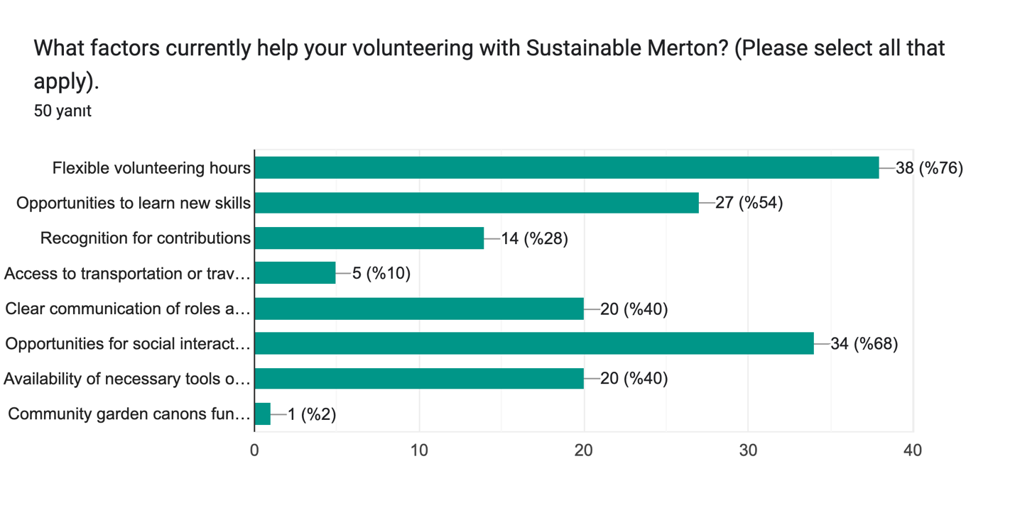

The survey results reveal several key facilitators that support volunteers in their roles with Sustainable Merton. According to the graph, flexible volunteering hours emerged as the most significant factor, cited by 76% of respondents, followed by opportunities for social interaction (68%) and learning new skills (54%). Other notable facilitators include clear communication of roles and expectations and the availability of necessary tools and resources, both mentioned by 40% of respondents. Open-ended responses further highlight additional insights: volunteers appreciate flexibility in scheduling, clearer project feedback, and recognition for their contributions. Suggestions for improvement include introducing more environmental/conservation projects, organizing volunteer staff meetings, and enhancing community engagement through shared activities like growing and distributing food. Some volunteers also emphasized the importance of better advertising for Sustainable Merton’s work and fostering a sense of independence in their roles. These responses collectively underscore the need for tailored strategies to enhance volunteer satisfaction and engagement while addressing specific areas for improvement.

Formlar yanıt grafiği. Soru başlığı: What barriers, if any, prevent or limit your engagement in volunteering?
(Please select all that apply.). Yanıt sayısı: 50 yanıt.

The survey results indicate key barriers that limit or prevent engagement in volunteering. The most significant barrier, identified by 72% of respondents, is a **lack of time due to personal commitments**, which highlights the competing demands volunteers face in their daily lives. Other notable barriers include **unclear communication about opportunities** (12%), **limited availability of resources** (10%), and a **lack of recognition or feedback** (10%). Accessibility issues and language or communication difficulties were mentioned by 6% and 4% of respondents, respectively, while **lack of financial support for transport** was identified by 4%.

Some volunteers also provided open-ended insights, emphasizing challenges like balancing **full-time work commitments**, **financial obligations**, or a need for clearer guidance and direction. While a minority indicated they are satisfied with their current engagement level, these responses collectively suggest a need for Sustainable Merton to address key barriers by providing more flexible volunteering schedules, clearer communication, and enhanced support for volunteers to make participation more accessible and rewarding.

In addition to the survey’s predefined barriers, volunteers shared several additional challenges through open-ended responses. **Time constraints** remain the most frequently mentioned obstacle, reflecting the difficulty of balancing volunteering with personal and professional commitments. Financial limitations were also highlighted, with one volunteer noting they would engage full-time if it were financially viable. Several respondents pointed out a lack of **awareness about volunteering opportunities**, including unclear communication on the website and insufficient engagement beyond specific social spheres.

Some responses suggest organizational challenges, such as **contradictory guidance from the council**, the absence of **volunteer staff meetings**, and a desire for better insights into how their contributions impact the community. One volunteer emphasized the importance of inclusivity, sharing an incident where an autistic individual faced barriers to participation. Additionally, there were concerns about volunteering being perceived as catering primarily to more affluent areas of Merton and overlooking hidden disabilities.

These insights underline the importance of addressing logistical, financial, and communication barriers while fostering inclusivity and providing clear, consistent guidance to create a more supportive and accessible volunteering environment.

Formlar yanıt grafiği. Soru başlığı: In what ways can Sustainable Merton provide better support to help you overcome the challenges you face?
(Select all that apply). Yanıt sayısı: 50 yanıt.

The survey results highlight various ways in which Sustainable Merton can better support its volunteers to overcome challenges. The most frequently suggested area for improvement is **creating more opportunities for social interaction** (44%), followed closely by **improving communication about opportunities** (42%). These findings underline the importance of fostering a strong sense of community and ensuring clear, accessible communication.

Other significant suggestions include **offering more flexible volunteering schedules** (30%), which aligns with the frequent barrier of time constraints, and **recognizing volunteer contributions** (20%), emphasizing the value of appreciation and acknowledgment. Additionally, **providing financial support for transport** and **better tools or resources** were each suggested by 14% of respondents, indicating the need for tangible support in facilitating volunteering activities.

A small proportion of respondents noted that they could not think of additional suggestions (8%), while a few open-ended responses emphasized the value of inclusivity and teamwork, such as allowing broader participation and improving collaboration across teams. These insights point to opportunities for Sustainable Merton to enhance volunteer satisfaction by addressing logistical challenges, improving communication, and strengthening the social and community aspects of volunteering.

1. **Volunteering Demographics**

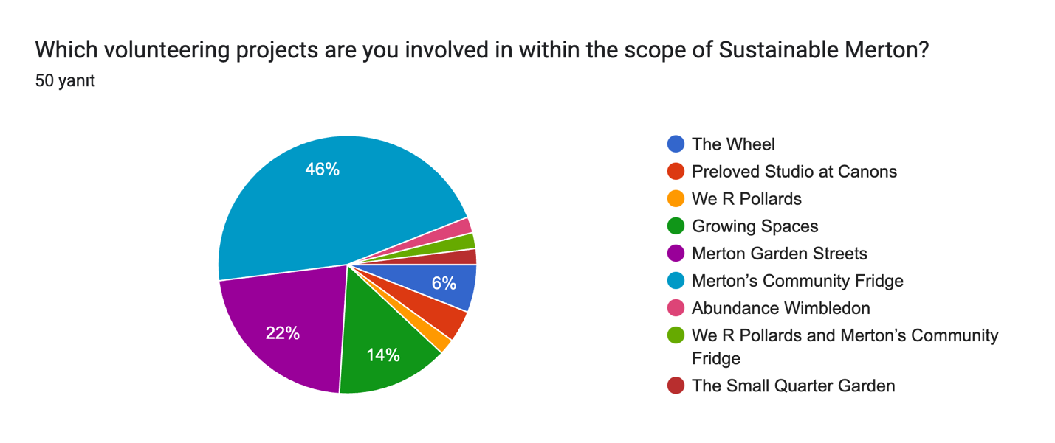

The pie chart provides an overview of the various volunteering projects under Sustainable Merton and the percentage of respondents involved in each. The majority of volunteers (46%) participate in Merton’s Community Fridge, indicating this is the most popular and impactful initiative. The next most common project is Merton Garden Streets, engaging 22% of respondents, reflecting its significant appeal among volunteers.

Other projects, such as We R Pollards (14%) and Growing Spaces (6%), have smaller but meaningful participation. A few volunteers are involved in more niche activities, including The Wheel, Preloved Studio at Canons, Abundance Wimbledon, We R Pollards and Merton’s Community Fridge, and The Small Quarter Garden, each accounting for a smaller share of respondents.

This distribution highlights the diverse range of opportunities provided by Sustainable Merton, with some projects having broader engagement, while others cater to more specialized interests within the volunteer community.

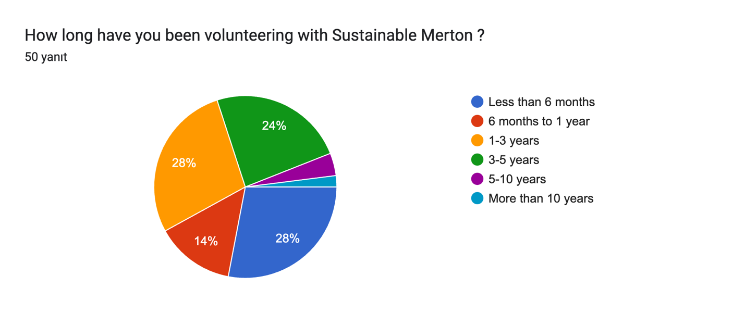

The pie chart illustrates the distribution of how long volunteers have been involved with Sustainable Merton. The largest segments are tied at 28% each, representing volunteers who have been involved for less than six months and those volunteering for 1–3 years. Another significant group, comprising 24%, has been involved for 3–5 years, indicating a solid retention rate over the medium term.

Smaller segments include those who have volunteered for 6 months to 1 year (14%) and long-term volunteers, with 5–10 years and more than 10 years accounting for a minimal share. This distribution suggests that Sustainable Merton has a healthy mix of newer and moderately experienced volunteers, while there may be opportunities to engage more individuals for extended commitments beyond five years.

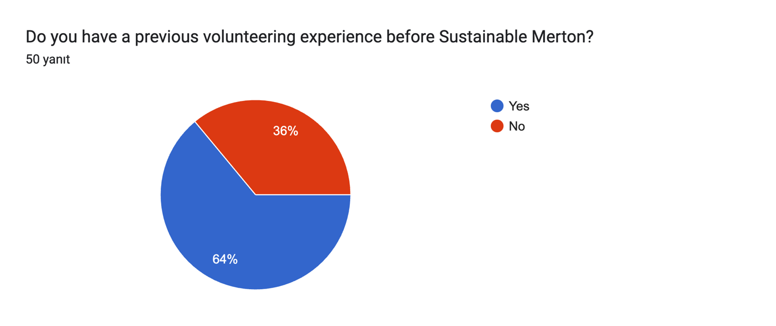

The pie chart shows that the majority of respondents (**64%**) had prior volunteering experience before joining Sustainable Merton, while **36%** did not. This indicates that Sustainable Merton attracts individuals with existing volunteer backgrounds, suggesting they may already have a predisposition toward community engagement and environmental causes. At the same time, a substantial proportion of first-time volunteers highlights the organization’s ability to appeal to newcomers, potentially broadening its volunteer base and fostering initial participation in sustainability-focused activities.

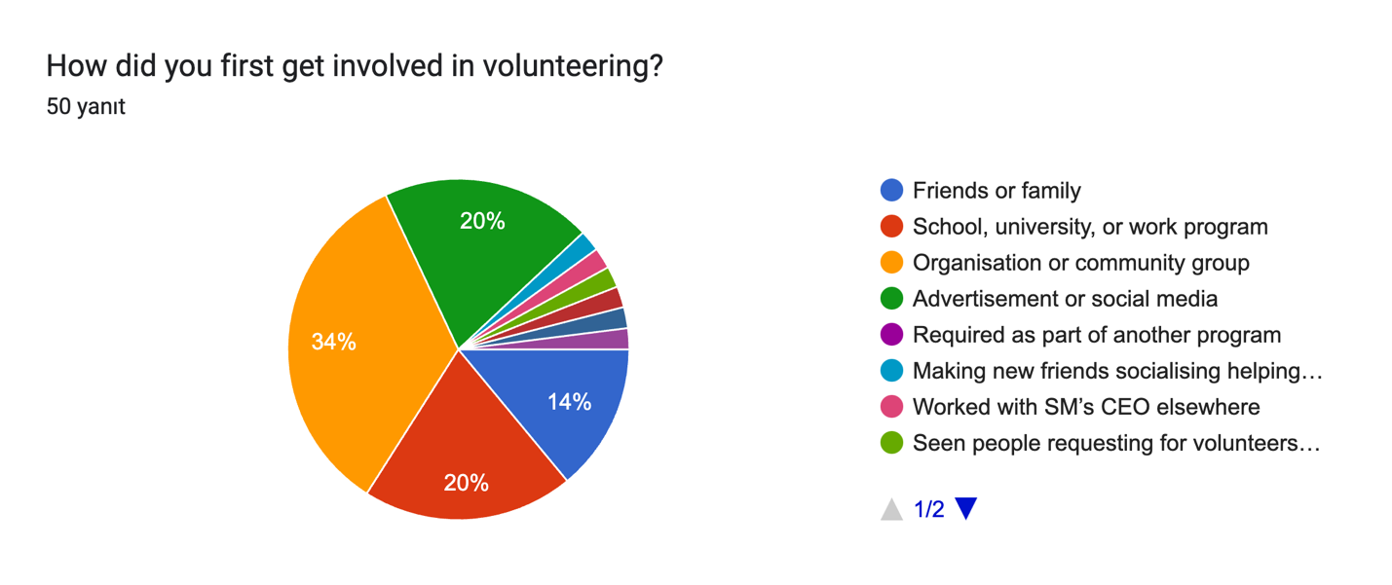

The pie chart illustrates how volunteers first got involved in volunteering. The largest share, **34%**, joined through an **organization or community group**, highlighting the central role these entities play in engaging volunteers. Another significant group, **20%**, began through **advertisements or social media**, emphasizing the importance of digital outreach in modern volunteer recruitment.

**Friends or family** (14%) and **school, university, or work programs** (20%) also play critical roles in introducing individuals to volunteering, demonstrating the influence of personal connections and educational/work environments. Smaller segments reflect diverse entry points, such as being **required as part of another program** or through unique situations like **working with Sustainable Merton’s CEO elsewhere** or **seeing requests for volunteers in the community**. These insights suggest that community connections, targeted advertising, and leveraging educational/work networks are effective strategies for volunteer recruitment.

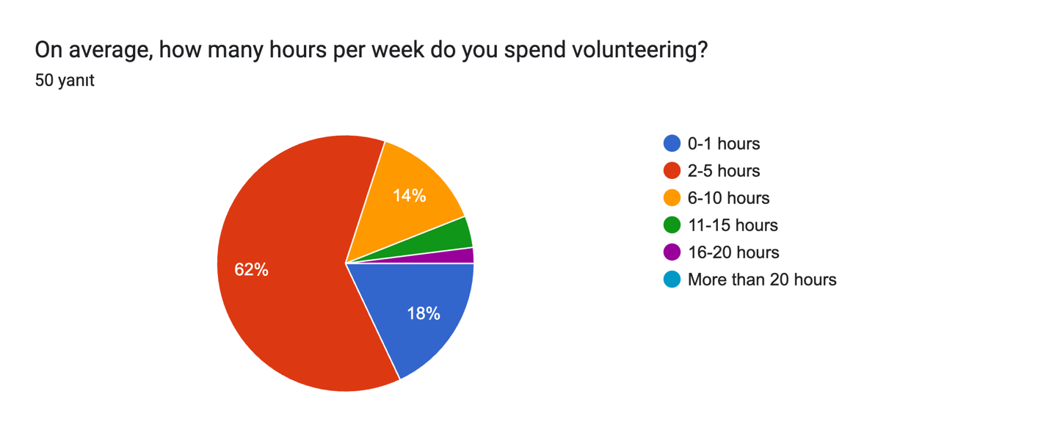

The pie chart shows the average weekly hours volunteers dedicate to Sustainable Merton. The majority of respondents (**62%**) spend **2–5 hours per week** volunteering, highlighting the part-time nature of most contributions. A smaller proportion (**18%**) volunteers for **0–1 hour**, while **14%** contributes **6–10 hours** weekly. Only a few volunteers dedicate significant time, with **11–15 hours** and **16–20 hours** each accounting for a minimal share.

These findings indicate that most volunteers engage at a manageable, part-time level, which aligns with the flexibility emphasized in other parts of the survey. Efforts to increase engagement might involve encouraging volunteers with smaller time commitments to gradually increase their involvement or creating micro-volunteering opportunities for those with limited availability.

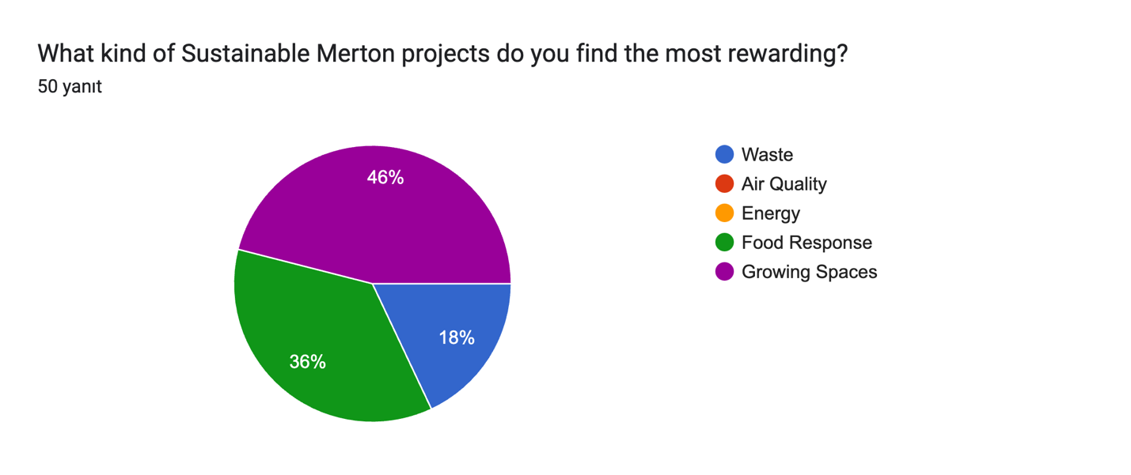

The pie chart shows which types of Sustainable Merton projects volunteers find the most rewarding. The majority of respondents (**46%**) identified **Growing Spaces** as the most rewarding, emphasizing the appeal of hands-on, community-centered environmental work. This is followed by **Food Response** projects, which were selected by **36%** of respondents, highlighting the impact and satisfaction derived from addressing food security and community needs.

Smaller segments represent projects focused on **Waste** (18%), while initiatives related to **Air Quality** and **Energy** were not highlighted as the most rewarding. These results suggest that projects involving tangible, direct contributions to the community and environment resonate most with volunteers, offering valuable insights for prioritizing future project designs and resource allocation.

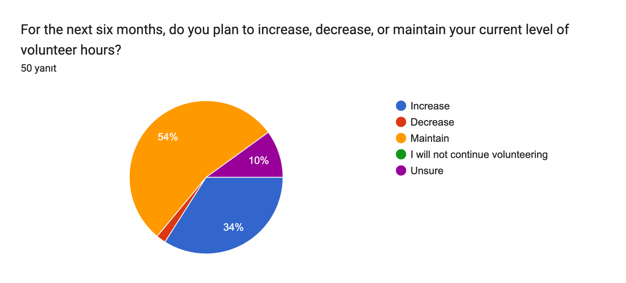

The chart reflects volunteers’ intentions regarding their level of commitment over the next six months. A majority (**54%**) plan to **maintain** their current level of volunteer hours, indicating satisfaction with their current engagement. A significant proportion (**34%**) expressed an intention to **increase** their hours, suggesting a strong sense of motivation and potential for greater involvement.

A small segment (**10%**) is **unsure** about their future engagement, while a minimal share intends to **decrease** their hours or discontinue volunteering. These findings highlight overall positive engagement levels among volunteers, with opportunities to encourage those aiming to increase their involvement and address the concerns of the few considering reduced participation.

Formlar yanıt grafiği. Soru başlığı: In the next two years are you likely to continue volunteering with this organisation?
. Yanıt sayısı: 50 yanıt.

The chart illustrates volunteers’ likelihood of continuing to volunteer with Sustainable Merton over the next two years, on a scale of 1 to 7. A majority (**56%**) gave the highest rating of **7**, indicating strong commitment to remaining involved with the organization. Another **18%** rated their likelihood as **6**, further highlighting positive engagement and intent to continue.

Smaller groups rated their likelihood as **5** (10%) or **4** (10%), showing moderate levels of commitment, while very few volunteers expressed low likelihood ratings (2% rated **2**, and none rated **1**). These results suggest that most volunteers have a strong intention to continue their engagement, reflecting high satisfaction and alignment with Sustainable Merton’s mission. Addressing the needs of volunteers with moderate or lower ratings could further enhance retention.

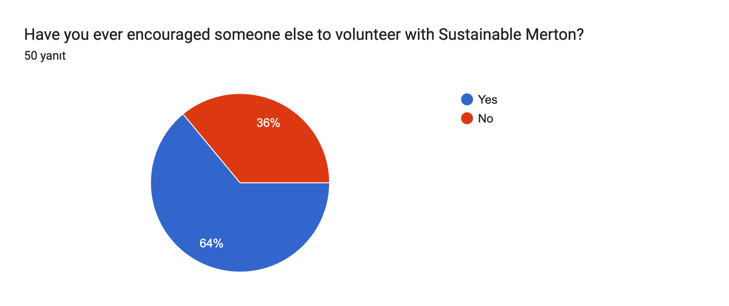

The pie chart shows that a majority of volunteers (**64%**) have encouraged someone else to volunteer with Sustainable Merton, reflecting strong advocacy and satisfaction among this group. Meanwhile, **36%** have not encouraged others to join. This demonstrates that while many volunteers are enthusiastic promoters of the organization, there is an opportunity to further engage and empower the remaining group to act as ambassadors for recruiting new participants. Enhanced communication about the impact of volunteers’ efforts and sharing success stories could help increase advocacy among all volunteers.

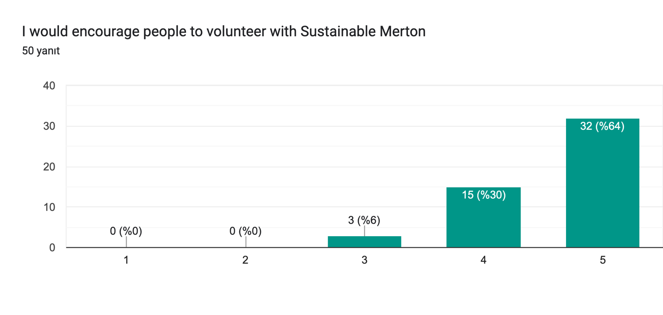

The chart reveals strong advocacy among volunteers for Sustainable Merton. A significant majority (**64%**) gave the highest rating of **5**, indicating they would highly recommend others to volunteer. Another **30%** rated their willingness as **4**, suggesting a high level of enthusiasm and satisfaction. Only **6%** rated their likelihood to encourage others as **3**, while no respondents rated it lower than that.

These results highlight the positive experiences of volunteers and their confidence in recommending Sustainable Merton to others, reflecting well on the organization’s impact and volunteer engagement practices. Leveraging this goodwill through referral programs or testimonials could further strengthen recruitment efforts.

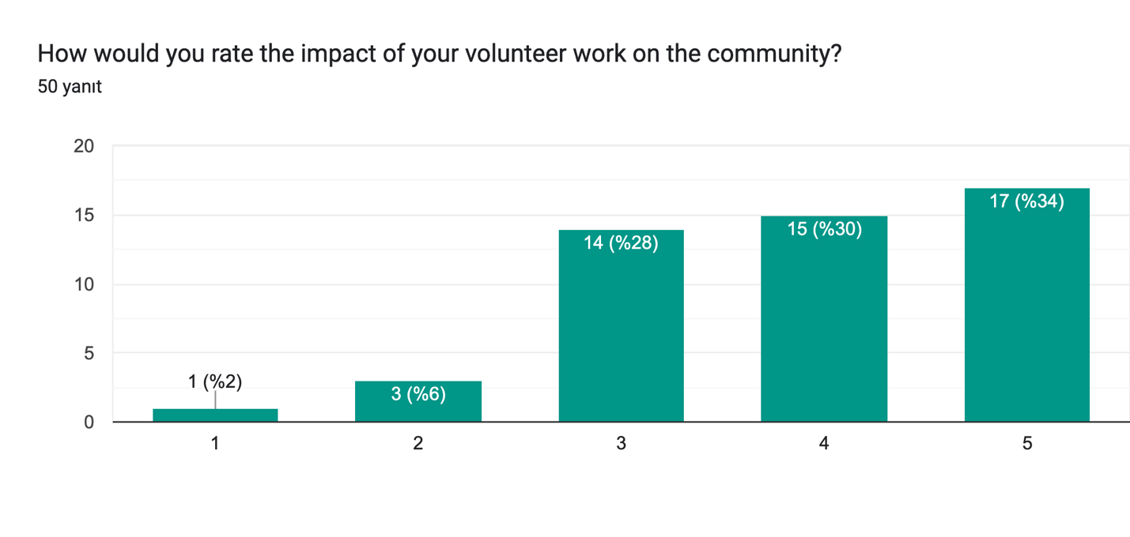

The chart shows how volunteers perceive the impact of their work on the community. A significant majority of respondents rated the impact positively, with **34%** giving the highest rating of **5** and **30%** rating it as **4**. Another **28%** provided a moderate rating of **3**, while a small minority rated the impact as **2** (6%) or **1** (2%).

These results indicate that most volunteers believe their contributions are making a meaningful difference, which aligns with high levels of engagement and satisfaction observed in other survey responses. However, the lower ratings from a small group suggest there may be room to enhance communication around the tangible outcomes of volunteer efforts to reinforce their sense of impact.

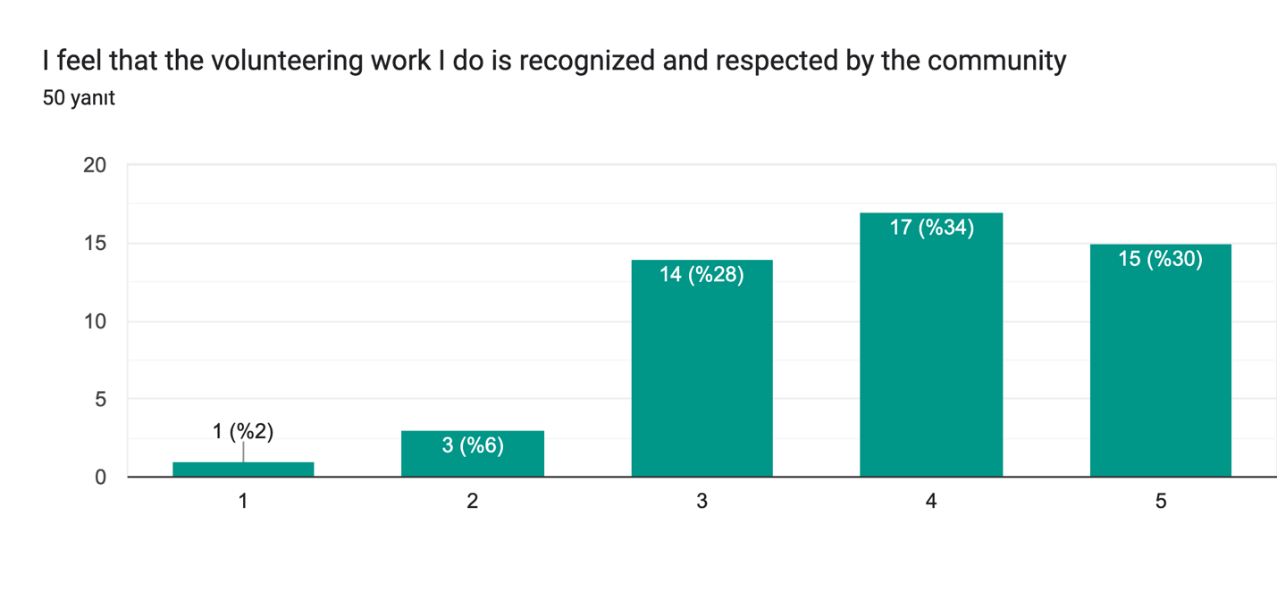

The chart reflects how volunteers perceive the recognition and respect their work receives from the community. A majority of respondents provided positive ratings, with **34%** rating it as **4** and **30%** giving the highest rating of **5**. This indicates that many volunteers feel valued for their contributions.

However, a notable portion (**28%**) rated their experience as moderate (**3**), and a small minority (**6%** and **2%**) rated it negatively (**2** or **1**, respectively). These results suggest that while most volunteers feel appreciated, there may be opportunities to enhance recognition efforts to ensure all volunteers feel their work is acknowledged and respected. Initiatives such as public acknowledgment, personalized feedback, or celebrating achievements could help address this gap.

* + **Analyze relationships between:**
    - Project involvement and motivations using chi-square tests.

A chi-square test was conducted to examine the relationships between **Project Involvement** and six motivational dimensions: Career, Social, Values, Understanding, Enhancement, and Protection. To perform the analysis, motivation scores were categorized into three bins (Low, Medium, and High) to create a contingency table for each dimension against Project Involvement levels. The chi-square statistic and corresponding p-values were calculated for each test to determine statistical significance.

The results revealed a significant relationship between **Project Involvement** and **Motivations - Understanding**, suggesting that volunteers’ levels of involvement are associated with their motivation to gain a deeper understanding through volunteering. No significant relationships were found between Project Involvement and the other motivational dimensions. This indicates that, while most motivations do not vary significantly with project involvement levels, the desire for understanding plays a notable role in shaping the level of engagement volunteers commit to Sustainable Merton projects.

* + - Hours volunteered with satisfaction, engagement, and demographic variables using linear regression.

A series of chi-square tests were conducted to examine the relationships between **Hours** spent volunteering and various engagement and satisfaction dimensions, including **Engagement - Vigor**, **Engagement - Dedication**, **Engagement - Absorption**, **Satisfaction - Task**, and **Satisfaction - Organisation**. For the analysis, the engagement and satisfaction scores were categorized into three discrete bins (Low, Medium, High), and contingency tables were created for each dimension against the numerical representation of Hours.

The results revealed no statistically significant relationships () between Hours and any of the engagement or satisfaction dimensions. This suggests that the level of time commitment (measured in hours) does not significantly influence the levels of engagement or satisfaction among volunteers. While this finding indicates a general consistency in engagement and satisfaction across different levels of involvement, it may also point to other factors, such as individual motivations or project preferences, being more critical determinants of these outcomes.

1. **Sustainability Awareness**

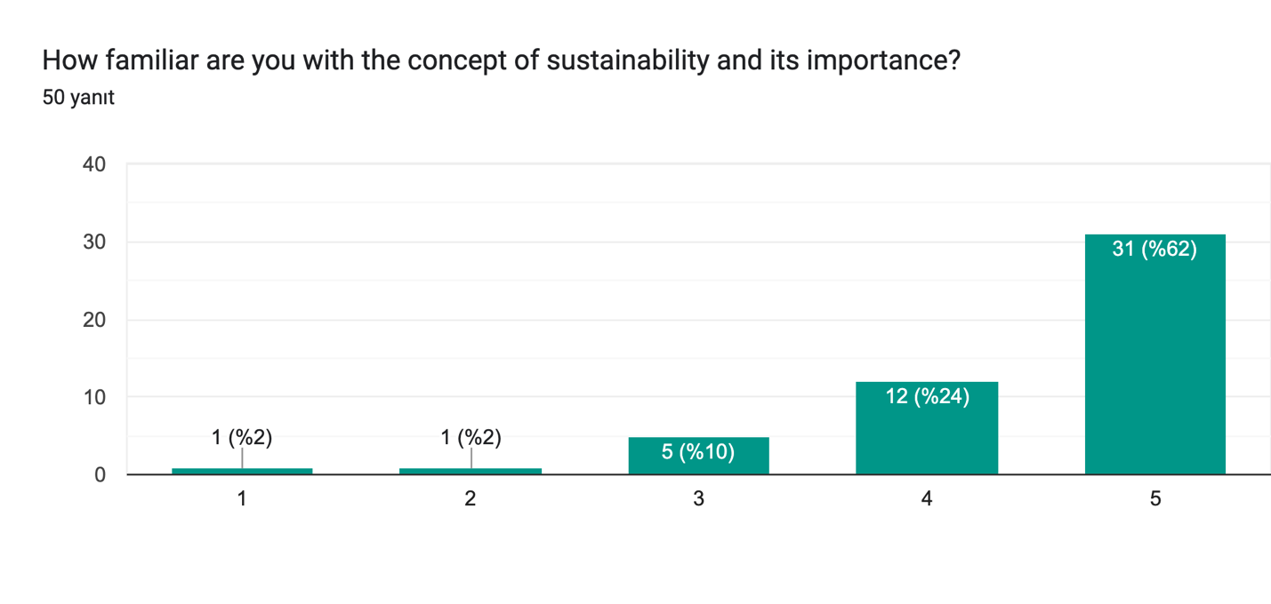

The chart highlights respondents’ familiarity with the concept of sustainability and its importance. The majority (62%) rated their familiarity as 5, indicating a high level of awareness. Another 24% rated their familiarity as 4, suggesting that most respondents have a strong understanding of sustainability. A smaller percentage (10%) rated their familiarity as 3, while very few respondents (2% each) gave the lowest ratings of 1 or 2. This data suggests that the volunteer base generally has a solid grasp of sustainability, with minimal gaps in awareness.

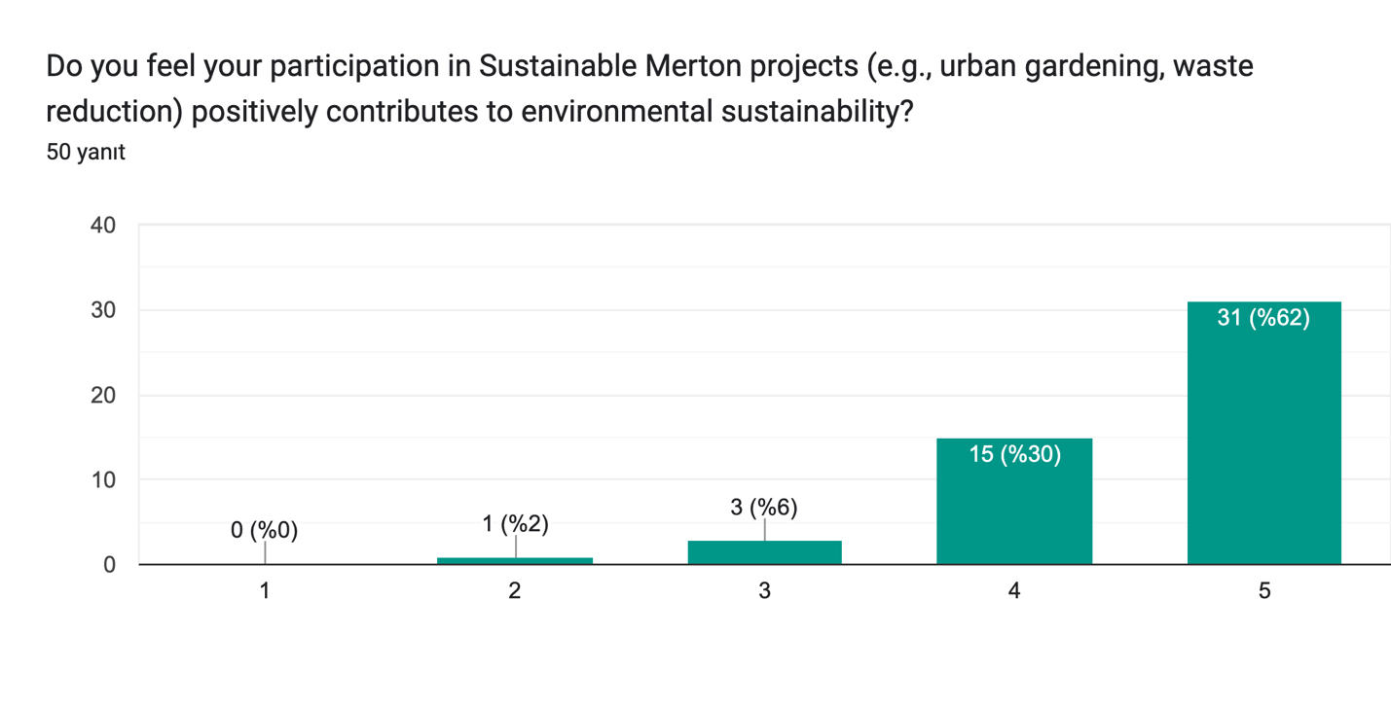

The chart highlights respondents’ perceptions of how their participation in Sustainable Merton projects contributes to environmental sustainability. A majority (**62%**) rated their contribution as **5**, indicating strong confidence in the positive impact of their involvement. Another **30%** rated it as **4**, reinforcing this sense of meaningful contribution. A small portion (**6%**) rated it as **3**, while very few (**2%**) rated it as **2**, and none rated it as **1**. These findings demonstrate that most volunteers believe their efforts significantly benefit sustainability, with minimal doubts about their impact.

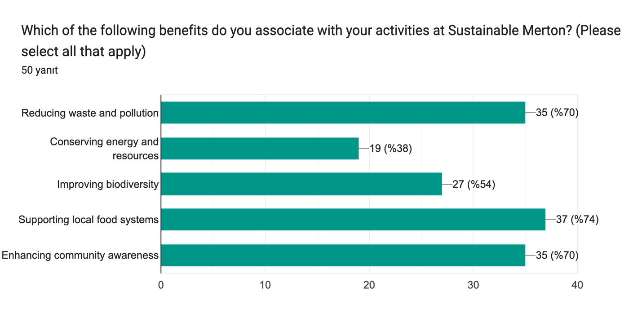

The chart highlights the benefits that volunteers associate with their activities at Sustainable Merton. The most commonly recognized benefit is **supporting local food systems**, selected by **74%** of respondents. This is followed closely by **reducing waste and pollution** and **enhancing community awareness**, both identified by **70%** of respondents.

Additionally, **improving biodiversity** was recognized by **54%**, while **conserving energy and resources** was noted by **38%**. These responses demonstrate that volunteers perceive their contributions as having a broad and meaningful impact across various aspects of environmental sustainability and community well-being.

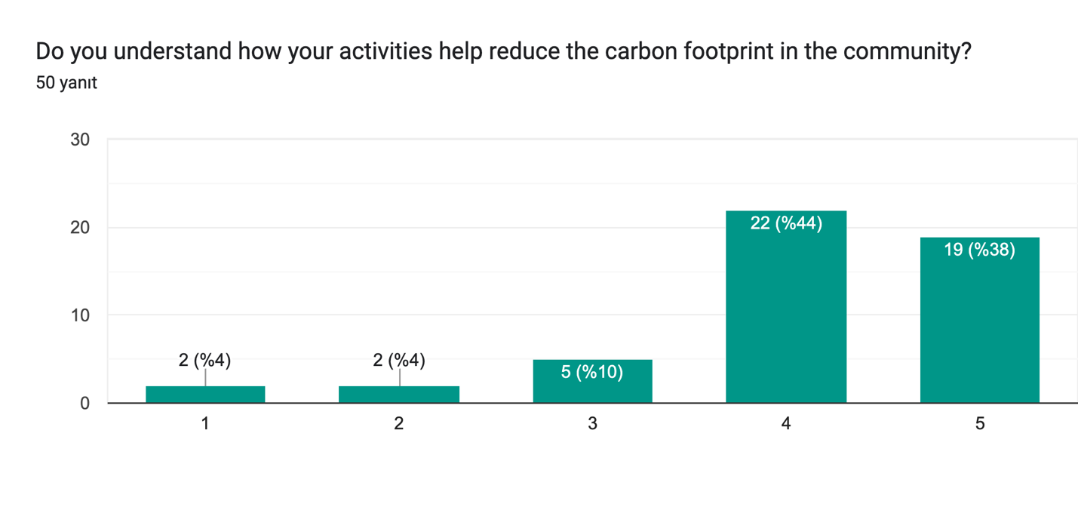

The chart illustrates respondents’ understanding of how their activities help reduce the community’s carbon footprint. A majority rated their understanding as positive, with **44%** selecting a score of **4** and **38%** selecting **5**, indicating strong awareness. A smaller portion (**10%**) rated their understanding as moderate (**3**), while a very small minority rated it as **2% each** for the lowest scores of **1** and **2**. These results suggest that most volunteers have a good understanding of their impact, although there is still room to enhance clarity and communication for a few individuals.

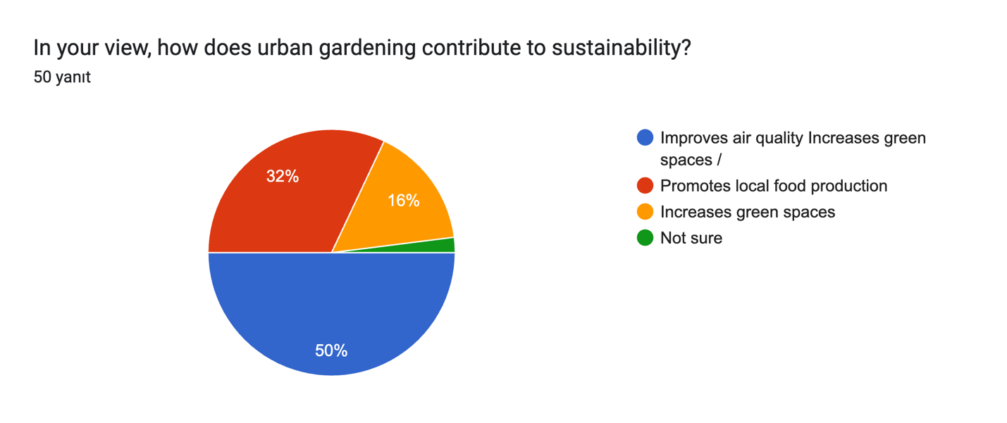

The chart demonstrates respondents’ views on how urban gardening contributes to sustainability. A majority (**50%**) believe that urban gardening **improves air quality and increases green spaces**. Another significant portion (**32%**) associates urban gardening with **promoting local food production**. A smaller group (**16%**) focuses on **increasing green spaces**, while a minimal percentage indicates being **not sure** about its impact. These findings highlight that most participants see urban gardening as a multifaceted activity with environmental and community benefits, particularly in improving air quality and supporting local food systems.

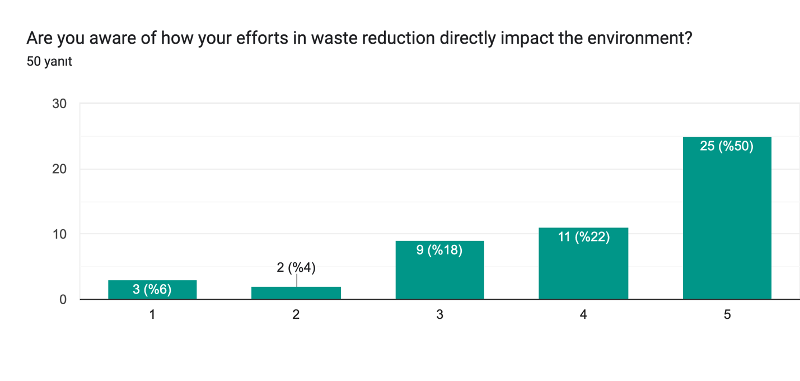

The chart illustrates respondents’ awareness of how their efforts in waste reduction directly impact the environment. Half of the participants (**50%**) rated their awareness as **5**, indicating a strong understanding of their environmental impact. Another **22%** rated it as **4**, reinforcing this high level of awareness. A smaller portion (**18%**) selected **3**, while **6%** and **4%** chose the lowest levels of awareness (**1** and **2**, respectively). These findings highlight that most volunteers have a clear understanding of the environmental benefits of waste reduction, although a small minority may benefit from further education or communication on this topic.

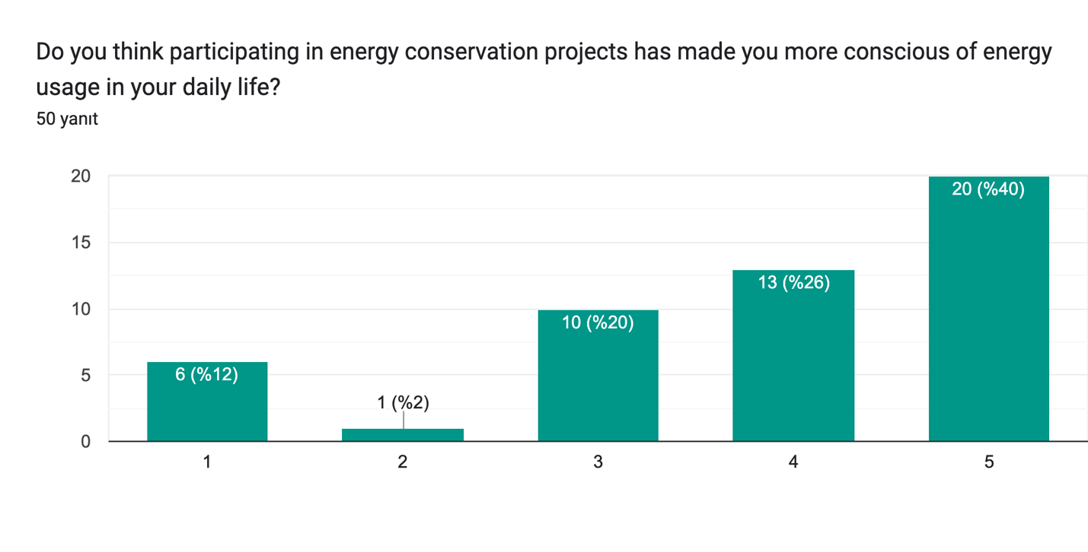

The chart highlights respondents’ perceptions of whether participating in energy conservation projects has increased their consciousness of energy usage in daily life. A substantial portion (**40%**) rated their increased consciousness as **5**, while another **26%** gave a rating of **4**, showing a strong positive impact overall. Around **20%** rated their awareness as **3**, indicating moderate influence. However, **12%** rated it as **1**, and a minimal **2%** rated it as **2**, suggesting limited or no impact for a small minority. These findings suggest that energy conservation projects have significantly influenced most participants’ daily energy consciousness, although some individuals remain less affected.

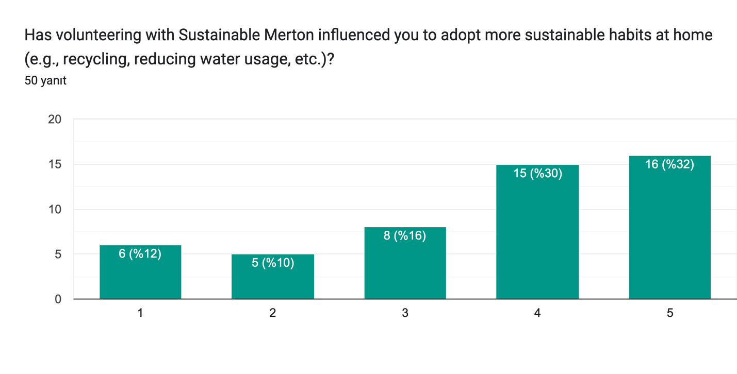

The chart reflects the influence of volunteering with Sustainable Merton on adopting more sustainable habits at home, such as recycling and reducing water usage. A significant portion of respondents rated this influence highly, with **32%** selecting **5** and **30%** selecting **4**, indicating a strong positive impact. A smaller group (**16%**) rated the influence as moderate (**3**), while **10%** and **12%** rated it as **2** and **1**, respectively, showing minimal or no effect. These results suggest that volunteering has positively encouraged sustainable behaviors for the majority, though a minority may require additional support or education to adopt such habits.

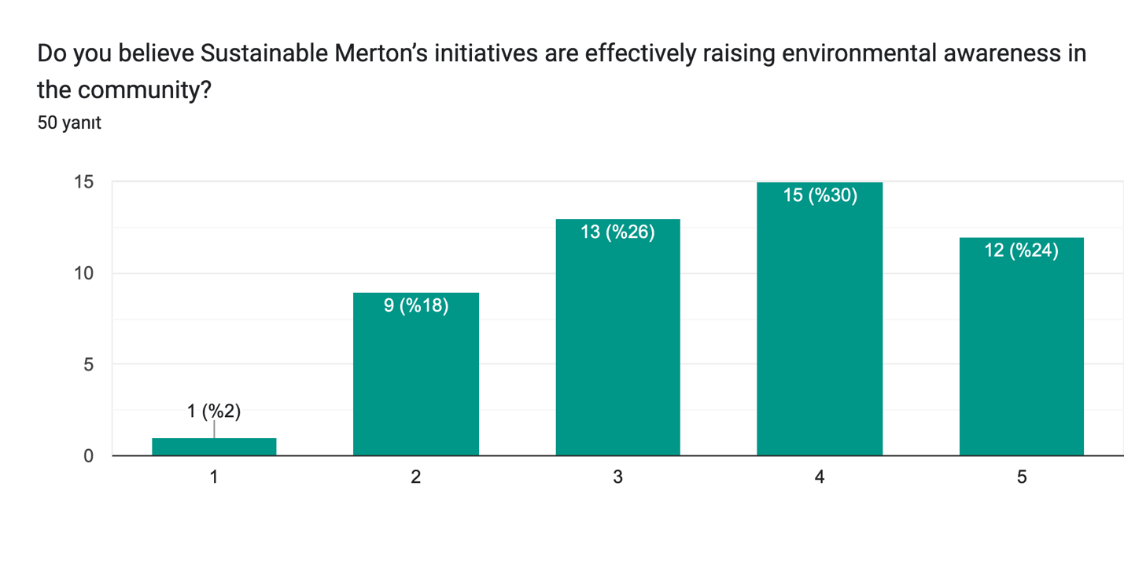

The chart reflects respondents’ perceptions of whether Sustainable Merton’s initiatives effectively raise environmental awareness in the community. A significant portion (**30%**) rated the effectiveness as **4**, while **24%** gave the highest rating of **5**, indicating a positive evaluation overall. Additionally, **26%** rated it as **3**, showing moderate agreement. A smaller group (**18%**) rated it as **2**, and only **2%** gave the lowest rating of **1**, indicating minimal effectiveness. These findings suggest that while most participants recognize the initiatives as impactful, there is room for improvement in broadening community awareness efforts.

The analysis examined the relationship between **Sustainability** scores and various variables, including motivations, engagement, satisfaction, and commitment, using Pearson’s correlation. Significant positive correlations were found between sustainability and all six motivational subscales (e.g., career, understanding, protection), engagement dimensions (vigor, dedication, absorption), and commitment, indicating that individuals with higher sustainability awareness tend to be more motivated, engaged, and committed. Notably, the strongest correlations were with **Engagement - Vigor** and **Motivations - Understanding**. However, sustainability awareness showed no significant correlation with satisfaction (tasks or organization), suggesting that while sustainability awareness aligns with greater engagement and commitment, satisfaction levels may depend on other factors. These findings highlight the importance of focusing on motivations and engagement to enhance sustainability initiatives.

1. **Communication Preferences**

The chart illustrates the frequency at which volunteers receive updates or communications from Sustainable Merton. A majority, 34%, reported receiving updates monthly, followed by 32% who receive updates weekly. Daily updates are received by 24% of respondents, while 8% stated they rarely receive updates. A very small fraction, 2%, indicated they never receive communication. This data highlights that most volunteers are regularly informed, with monthly and weekly updates being the most common, but a notable minority experience limited or no communication.

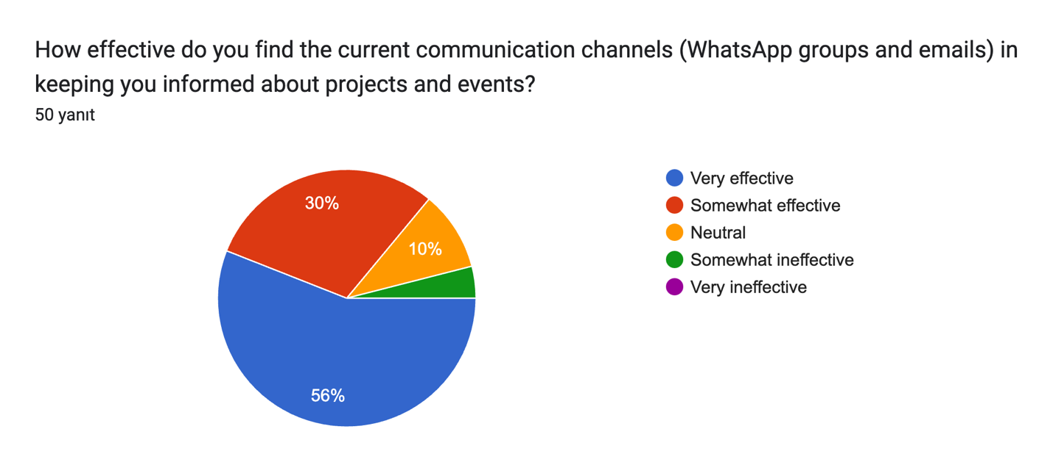

The chart illustrates how volunteers perceive the effectiveness of current communication channels, such as WhatsApp groups and emails, for staying informed about projects and events. A majority, 56%, found the communication channels “Very effective,” while 30% considered them “Somewhat effective.” A smaller portion, 10%, were neutral, and 4% deemed the channels “Somewhat ineffective.” None rated them as “Very ineffective.” This suggests that while most volunteers are satisfied with the communication channels, a small percentage perceive room for improvement.

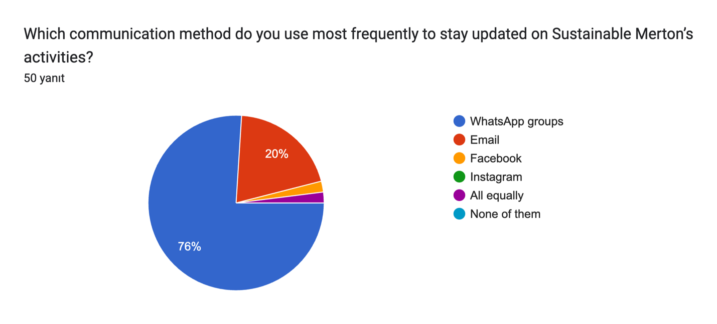

The chart highlights the most frequently used communication methods for staying updated on Sustainable Merton’s activities. WhatsApp groups are overwhelmingly the preferred method, with 76% of respondents using them. Email is the second most used method, with 20% of respondents relying on it. A small percentage mentioned Facebook, Instagram, or using all methods equally. No respondents indicated that they use none of the listed methods. This data underscores WhatsApp’s central role in Sustainable Merton’s communication strategy.

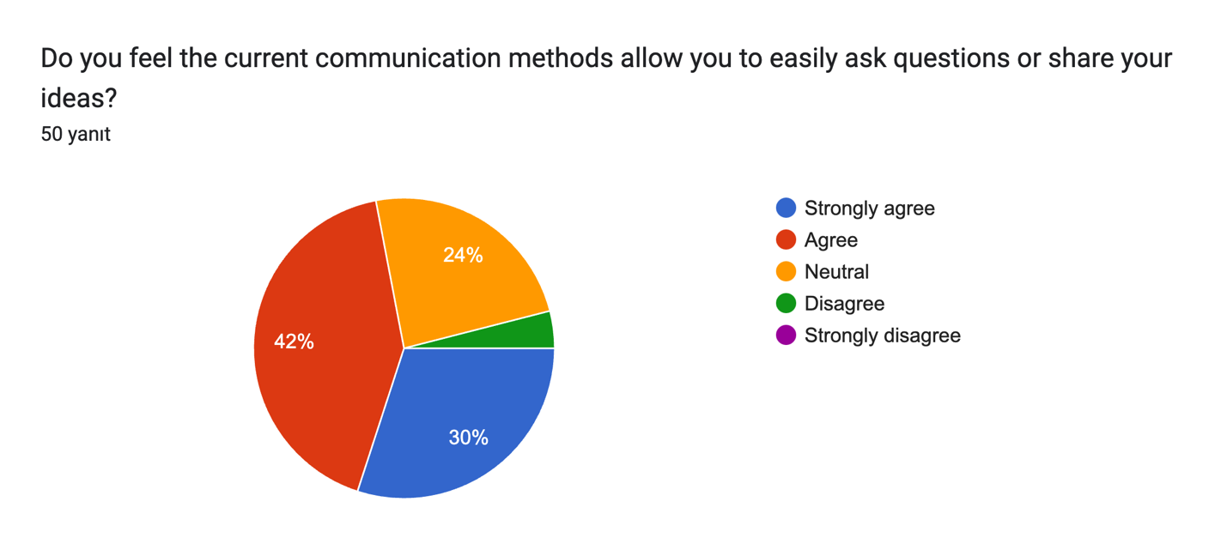

The chart reflects participants’ perspectives on whether the current communication methods enable them to ask questions or share ideas effectively. A majority, comprising 42%, agreed that these methods are effective, while 30% strongly agreed, indicating overall satisfaction. However, 24% of respondents were neutral, showing no strong opinion, and a smaller portion expressed dissatisfaction, with 2% disagreeing and 2% strongly disagreeing. This data suggests that while communication methods are generally well-received, there is room for improvement in engaging a segment of the participants who are neutral or dissatisfied.

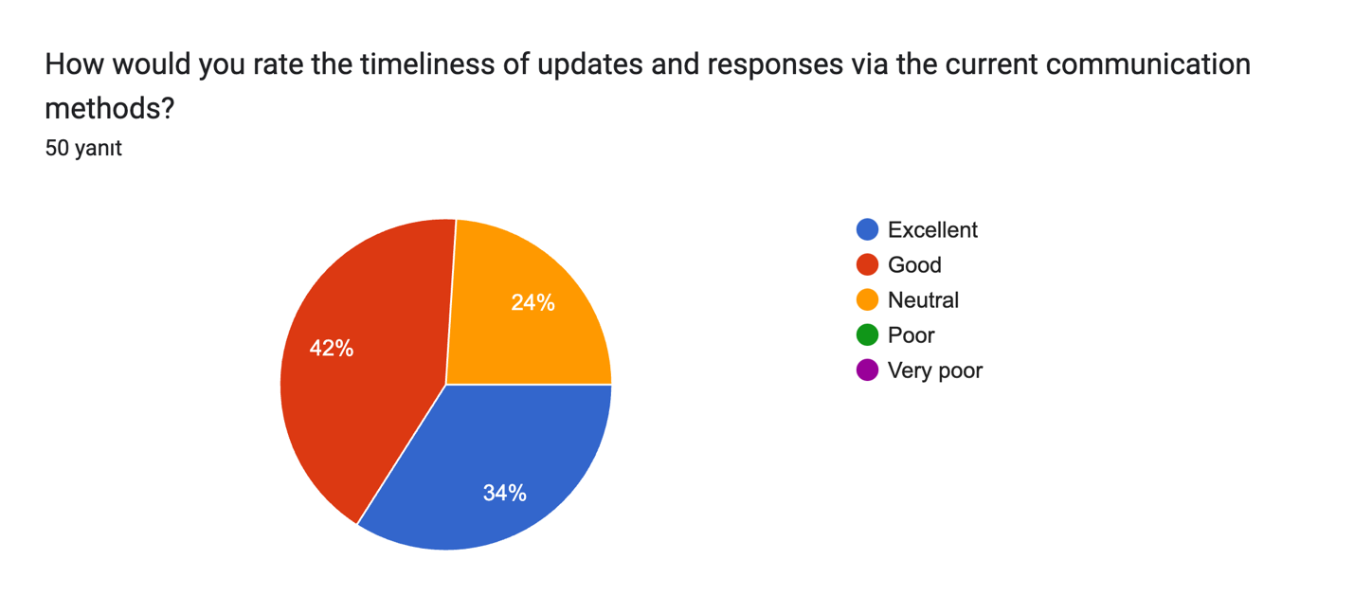

The chart illustrates participants’ ratings of the timeliness of updates and responses via current communication methods. A significant portion, 42%, rated the timeliness as “Good,” reflecting a general satisfaction. Meanwhile, 34% rated it as “Excellent,” showing high approval from this segment. However, 24% remained neutral, suggesting room for improvement. No respondents rated the timeliness as “Poor” or “Very poor,” indicating that the communication methods are functioning effectively but could still be optimized to engage neutral respondents.

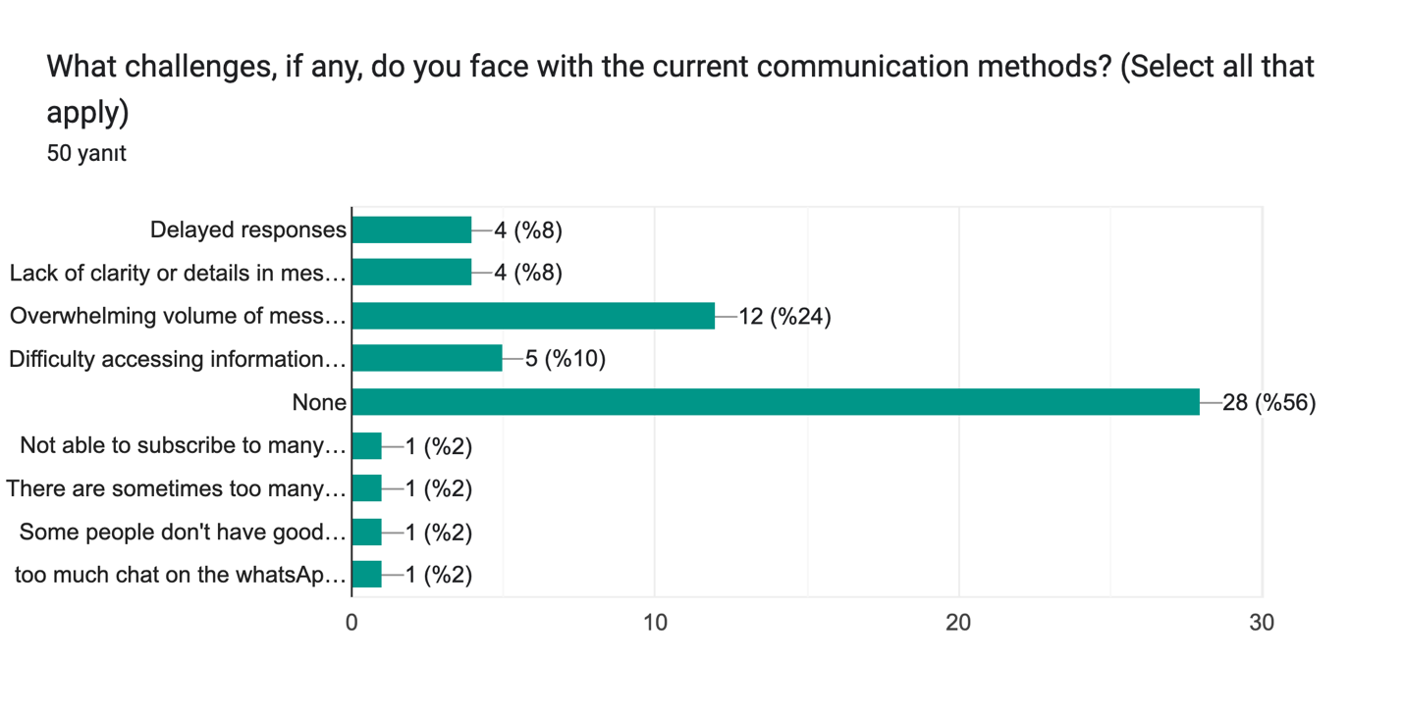

The chart highlights challenges faced by participants with Sustainable Merton’s current communication methods. A majority, 56%, reported no challenges, indicating that communication methods are effective for many. However, 24% noted an overwhelming volume of messages as a concern, while smaller percentages cited delayed responses (8%), lack of clarity or details in messages (8%), and difficulty accessing information (10%) as issues. Additional unique challenges mentioned include difficulty subscribing to updates, too much informal chat on WhatsApp, and uneven internet access. These findings suggest that while communication is largely effective, addressing message overload and improving clarity could enhance participant satisfaction.

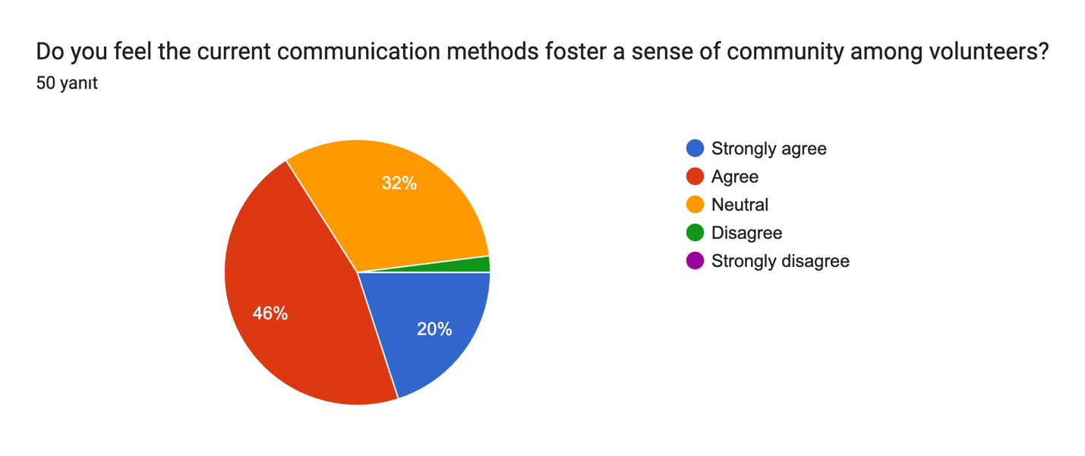

The chart reflects perceptions of whether current communication methods foster a sense of community among volunteers. A majority of respondents, 46%, agree that these methods promote community, while 20% strongly agree, demonstrating a generally positive sentiment. However, 32% remain neutral, suggesting room for improvement in enhancing the sense of belonging and connection. A minimal portion, 2%, disagrees, indicating that dissatisfaction with communication methods fostering community is relatively rare. This feedback highlights the importance of continuing efforts to strengthen community bonds through effective communication strategies.

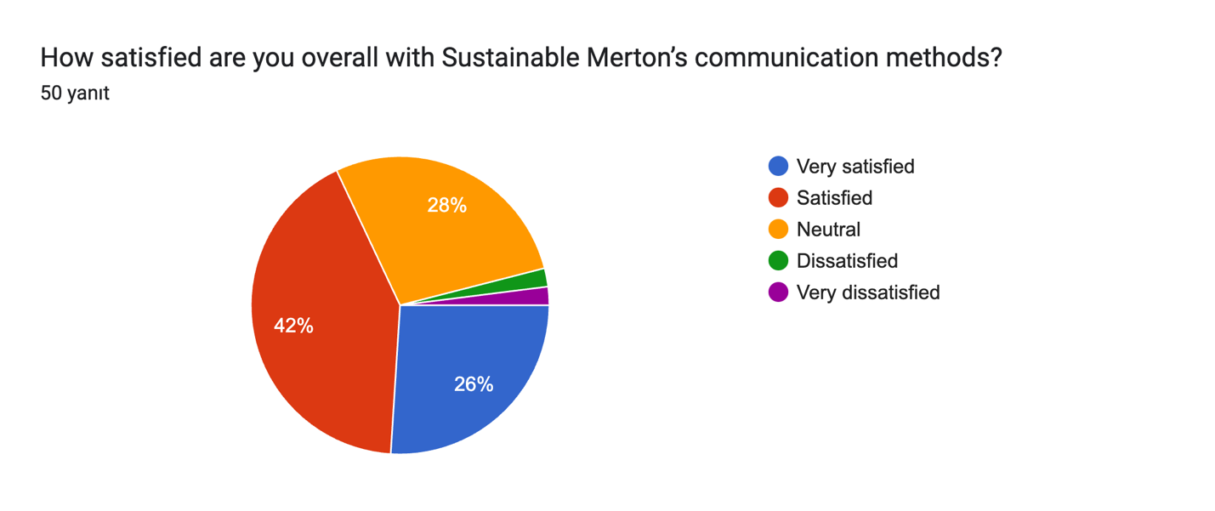

The chart illustrates overall satisfaction with Sustainable Merton’s communication methods. A combined 68% of respondents expressed satisfaction, with 26% being very satisfied and 42% satisfied. However, 28% remained neutral, indicating neither satisfaction nor dissatisfaction. Only a small proportion expressed dissatisfaction, with 4% dissatisfied and 2% very dissatisfied. This suggests that while the majority are content with the communication methods, there is an opportunity to address the needs of those who are neutral or dissatisfied to further enhance overall satisfaction.

The responses regarding improvements to Sustainable Merton’s communication methods reveal diverse suggestions. While several respondents (e.g., “None,” “N/A,” “Not sure”) expressed satisfaction with the current setup, others highlighted specific concerns. Common themes include managing the volume and focus of WhatsApp messages, such as separating social chats from project-specific communication or limiting off-topic discussions. Suggestions included creating centralized resources like a calendar or online platform for project information, sending email notifications alongside WhatsApp alerts, and improving public-facing communication to engage schools and wider audiences. A few respondents emphasized the need for concise, task-focused messages and better organization across groups. Overall, while many found WhatsApp effective, there is room to refine its use for clarity and reduced message volume.

The results indicate that the majority of respondents (66%) are open to exploring a more structured communication platform, such as WhatsApp Communities, for project-specific updates and general announcements. Meanwhile, 26% of participants are unsure about this potential change, and a small minority (8%) expressed opposition. This suggests a strong willingness among most respondents to consider improvements in communication methods, with some hesitance that may reflect a need for further clarification or demonstration of the proposed platform’s benefits.

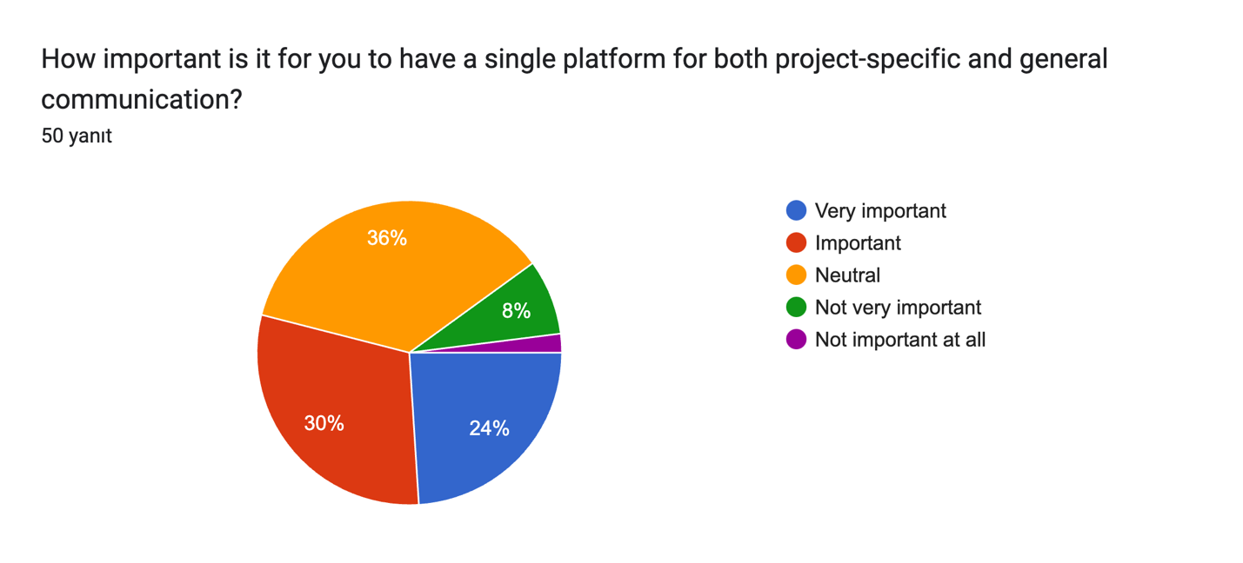

The results indicate that a significant portion of respondents value having a single platform for both project-specific and general communication, with 24% considering it “very important” and 30% viewing it as “important.” Meanwhile, 36% remain neutral on this matter, and smaller fractions—8% and 2%—deem it “not very important” or “not important at all,” respectively. These findings suggest that while a majority recognize the utility of a unified communication platform, a notable proportion of respondents are either indifferent or do not see it as a pressing need.

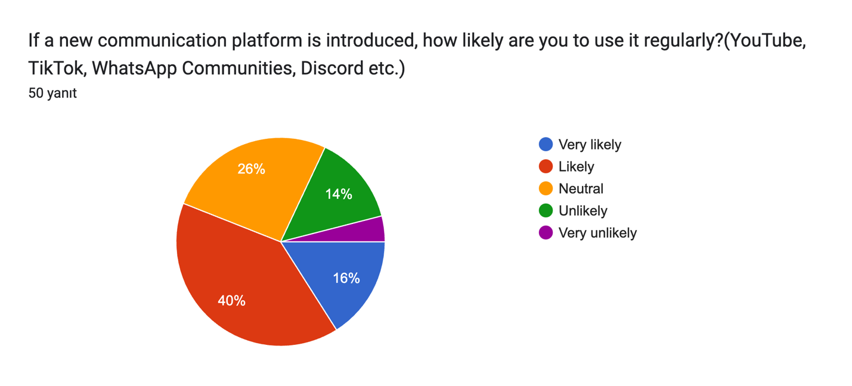

The results reveal a mixed level of willingness among respondents to adopt a new communication platform, such as WhatsApp Communities, Discord, or others. While 16% of respondents indicated they would be “very likely” to use such a platform, and 40% stated they are “likely,” a notable portion remains neutral at 26%. However, there is some resistance, with 14% and 4% indicating they are “unlikely” or “very unlikely” to use the platform, respectively. This suggests that while there is openness to exploring new communication tools, there may be challenges in achieving widespread adoption.

1. **Compare new volunteers to old volunteers:**

You conducted an independent t-test to explore whether there are significant differences between new volunteers (involved for less than one year) and old volunteers (involved for more than one year) across various metrics, including motivations, engagement, satisfaction, and commitment. The test compared the mean scores of these metrics between the two groups to identify key differences in their experiences and perceptions.

The results revealed significant differences in several areas. Old volunteers scored significantly higher on Motivations - Understanding, indicating they are more driven by the opportunity to understand the cause compared to new volunteers (*p = 0.003*). Additionally, old volunteers displayed stronger engagement, as reflected in higher scores for Engagement - Dedication (*p = 0.017*) and Engagement - Absorption (*p = 0.045*), suggesting they are more dedicated and immersed in their volunteer activities. Furthermore, old volunteers reported greater satisfaction with the organisation (*p = 0.026*).

Interestingly, new volunteers exhibited significantly higher levels of commitment compared to old volunteers (*p = 0.000*). This finding suggests that while newer volunteers may still be building their engagement and understanding of the organisation, they are highly committed to remaining involved.

On the other hand, no significant differences were observed for other metrics such as Motivations - Career, Social, Values, Enhance, and Protect, as well as Engagement - Vigor and Satisfaction - Task (all *p > 0.05*). These findings indicate that these factors are consistent across new and old volunteers.

In conclusion, the analysis highlights nuanced differences in volunteer experiences based on tenure. While old volunteers tend to show stronger engagement and satisfaction, newer volunteers are notably more committed. These insights provide valuable information for tailoring engagement and support strategies to volunteers at different stages of their journey.

1. **Open-Ended Questions**
   * **In your own words, what motivates you to volunteer?**

The motivations for volunteering center around several key themes. Many participants emphasize giving back to the community, highlighting the satisfaction of contributing to the betterment of their local environment and helping those less fortunate. A significant number of responses reflect a desire to make a positive impact, whether by improving green spaces, reducing waste, or addressing social inequalities like food insecurity.

Social connections also play a major role, as respondents value meeting like-minded individuals, building relationships, and working with others who share their values. Volunteering is also seen as a way to build confidence, learn new skills, and stay active and engaged, particularly among individuals who appreciate having something meaningful to do. Personal fulfillment is a common thread, with many participants describing the happiness, peace, and purpose they derive from helping others.

Additionally, there are motivations tied to specific interests, such as gardening, environmental sustainability, and reducing waste, which align with respondents’ hobbies and values. Finally, some participants express a sense of moral responsibility, noting that volunteering is simply the “right thing to do” and a way to set an example for others. Overall, the responses highlight a combination of altruistic, social, personal, and environmental motivations driving participants to volunteer.

The responses to the question “What motivates you to volunteer?” are strongly reflected in the top keywords, highlighting the key drivers behind participants’ motivations. The word “community” emerges as a central theme, emphasizing the importance of contributing to and being a part of a shared environment. Words like “help,” “helping,” “giving,” and “fortunate” underline the altruistic nature of volunteering, with many participants motivated by the desire to assist others and give back to those in need. “Difference,” “impact,” and “make” demonstrate a shared commitment to creating tangible, positive outcomes in their local communities and the environment.

The inclusion of terms such as “environment” and “food” suggests that sustainability and addressing food-related challenges are also significant motivators. Keywords like “enjoy,” “feel,” “good,” and “interesting” reflect the personal satisfaction and emotional benefits derived from volunteering, while “involved” and “local” point to the importance of being engaged in meaningful activities close to home. Overall, these keywords provide insight into the multifaceted motivations—spanning altruism, environmental impact, personal growth, and community engagement—that inspire individuals to volunteer.

The sentiment and thematic analysis of responses provide further insights into the motivations behind volunteering. The sentiment analysis reveals that the majority of responses express **positive emotions** (32 instances), showcasing a strong sense of fulfillment, joy, and purpose derived from volunteering. A smaller portion of responses are **neutral** (15 instances), which likely reflect practical or factual motivations, while **negative sentiment** (3 instances) is minimal, indicating that dissatisfaction or unfavorable experiences are rare among respondents.

The thematic analysis highlights **altruism** as the dominant theme, identified in 31 responses. This suggests that many volunteers are primarily motivated by the desire to help others, give back to the community, and make a meaningful impact. The remaining 19 responses fall under the **“other”** category, capturing motivations such as personal growth, learning new skills, or simply enjoying the activities. Together, the sentiment and thematic analyses illustrate that volunteering is largely driven by positive and altruistic motivations, with a smaller subset of responses focused on individual interests or less emotionally charged reasons.

* + **What other factors could further facilitate your volunteering with Sustainable Merton?**

The responses to the question “What other factors could further facilitate your volunteering with Sustainable Merton?” reflect a variety of suggestions and themes aimed at enhancing the volunteering experience.

Flexibility and Accessibility emerged as a recurring theme, with many respondents emphasizing the need for more flexible volunteering hours. Suggestions included offering opportunities on weekends and creating project-based roles that accommodate busy schedules. Some participants also mentioned that closer proximity to their homes and greater independence in volunteering activities would make participation easier and more appealing.

Improved Communication and Information was another key area of focus. Several respondents recommended better communication about available opportunities, such as providing clearer feedback through newsletters, enhanced outreach efforts, particularly in areas like Mitcham, and improving visibility of Sustainable Merton’s work beyond social media platforms. These changes were seen as critical to keeping volunteers informed and engaged.

Recognition and Support were highlighted by a few respondents who felt that more acknowledgment of volunteers’ contributions would boost morale. Suggestions included regular volunteer meet-ups, increased interaction with the organization, and greater understanding of the voluntary nature of their efforts. Leadership and organizational support were also mentioned as areas for improvement.

In terms of Expanded Opportunities, participants expressed interest in additional projects such as environmental and conservation work, outdoor activities, and roles with greater responsibilities. Ideas included introducing outreach projects, food-sharing activities, and opportunities that utilize diverse skill sets. Some respondents also suggested initiatives that encourage collaboration and engagement within the community.

Community and Social Interaction was a notable motivator for volunteers. Respondents highlighted the importance of fostering stronger connections among volunteers and with the local community. Regular staff meetings, social events, and opportunities to share experiences were suggested as ways to enhance the sense of community among volunteers.

Finally, Other Suggestions included better organization, increased collaboration with Merton Council, improvisation opportunities, ad hoc events, and a clearer understanding of project budgets. While some participants expressed satisfaction with the current system and did not feel additional changes were needed, the majority provided valuable insights into how flexibility, communication, recognition, and project variety could further facilitate their involvement.

The top keywords extracted from the responses highlight key themes and priorities for enhancing the volunteering experience with Sustainable Merton. Words such as **“community,” “volunteer,” “volunteering,”** and **“social”** emphasize the importance of fostering connections and social interactions among volunteers and within the local community.

Keywords like **“projects,” “growing,”** and **“spaces”** suggest a strong interest in expanding and diversifying project opportunities, particularly those related to environmental and outdoor activities, such as growing spaces and conservation work. Similarly, terms like **“opportunities”** and **“regular”** reflect a desire for consistent and varied chances to engage in meaningful work.

The mention of **“better,” “organisation,”** and **“interaction”** highlights a need for improved communication, coordination, and engagement within the organization. Suggestions for clearer communication, better outreach, and stronger connections between volunteers and leadership are reflected in these terms.

Practical considerations are also evident in keywords such as **“hours,” “time,” “home,”** and **“work,”** which point to the importance of flexibility, proximity, and balancing volunteering with personal and professional commitments. Finally, words like **“happy,” “good,”** and **“helps”** underscore the positive emotions and satisfaction that volunteers derive from contributing to the community and making a difference through their efforts. These keywords collectively provide a snapshot of volunteer priorities and areas for potential improvement.

The sentiment and thematic analysis of the responses provide further insight into what volunteers feel could enhance their experience with Sustainable Merton. The **sentiment analysis** reveals a predominantly positive outlook, with 27 responses expressing optimism and satisfaction with current efforts or constructive suggestions for improvement. Meanwhile, 21 responses were neutral, reflecting practical or factual suggestions without emotional undertones. Only 2 responses carried a negative sentiment, indicating minimal dissatisfaction or challenges faced by volunteers.

The **thematic analysis** highlights that the majority of responses fall under the **“other”** category (42), encompassing diverse suggestions such as flexibility, better communication, improved organization, and additional project opportunities. The theme of **altruism** (6 responses) reflects motivations tied to contributing to the community and making a difference. A smaller number of responses (2) were categorized under **“social,”** emphasizing the importance of interactions and relationships among volunteers and within the community.

Overall, the sentiment analysis underscores a largely positive and solution-oriented perspective among volunteers, while the thematic analysis showcases a broad range of ideas for improving the volunteering experience, with a focus on practical enhancements and community engagement.

* + **What additional features or improvements would you like to see in the communication methods?**

The responses to the question “What additional features or improvements would you like to see in the communication methods?” reveal several areas for potential enhancement in communication practices.

WhatsApp Usage was a central topic in many responses. Participants highlighted the need to optimize WhatsApp groups by separating them based on purpose, such as having one group for official updates and another for social interactions. There were concerns about message overload and off-topic discussions, with some suggesting that posts remain focused on shared aims to reduce unnecessary messages. A few respondents also emphasized limiting WhatsApp use to project-specific updates, such as the Community Fridge, to maintain relevance and clarity.

Clear and Efficient Communication was another recurring theme. Many volunteers expressed a desire for concise and actionable updates. Suggestions included sending task reminders more regularly via WhatsApp and providing notifications for important emails through the platform to ensure timely attention. Respondents emphasized that shorter and more targeted communication would enhance overall efficiency and engagement.

Some feedback focused on Improved Public and Internal Communication. While many felt communication with volunteers was effective, a few noted that Sustainable Merton could improve its outreach to the broader public, including schools and the local community. Suggestions included increasing publicity, engaging more actively with schools, and giving earlier notice about projects and events to encourage participation.

Additionally, respondents proposed the idea of Centralized Resources to streamline access to information. A centralized platform, such as an online resource hub or calendar, was suggested to allow volunteers to download project-specific materials, track events, and access relevant updates. This approach could reduce confusion caused by multiple communication channels and make information more accessible.

Finally, General Satisfaction and Neutral Feedback were expressed by many respondents. Some explicitly stated that WhatsApp was already an effective communication tool, while others indicated that they were satisfied with the current methods and had no specific suggestions for improvement.

The top keywords extracted from the responses highlight key priorities and concerns regarding communication methods. Words such as **“WhatsApp,” “group,”** and **“groups”** emphasize the central role of WhatsApp in volunteer communication, with many suggestions focused on optimizing its use, such as separating groups by purpose or improving message management. Similarly, terms like **“messages,” “important,”** and **“information”** reflect the need for clearer, more focused communication to ensure that critical updates are not lost in message overload.

The inclusion of **“community,” “projects,”** and **“Sustainable Merton”** underscores the broader context of volunteers’ engagement, suggesting a desire for better communication not only within volunteer groups but also with the local community and about ongoing projects. Keywords like **“social”** and **“separate”** point to a focus on balancing professional updates with opportunities for social interaction, while **“info”** and **“know”** highlight the importance of accessible and transparent information sharing.

Overall, these keywords provide insight into volunteers’ priorities, emphasizing streamlined communication, better organization of WhatsApp groups, and enhanced accessibility to project-related information and updates. These themes align with the feedback, showing a strong preference for improving clarity and efficiency in communication methods.

The **sentiment analysis** of the responses highlights a mix of perspectives on improving communication methods. The majority of responses are **neutral** (29), reflecting practical or factual suggestions, such as recommendations for improving WhatsApp group organization or increasing information accessibility. A smaller proportion of responses are **positive** (14), indicating satisfaction with current methods or constructive suggestions. Conversely, **negative sentiment** (7) responses reveal frustrations, particularly with issues like message overload, irrelevant discussions in WhatsApp groups, or insufficient outreach efforts.

The **thematic analysis** reveals that most responses fall under the **“other”** category (45), capturing a wide range of practical feedback on communication tools, group organization, and information clarity. The theme of **altruism** (4 responses) reflects motivations tied to improving communication for the benefit of the community or to better support Sustainable Merton’s mission. A single response categorized as **“social”** highlights the importance of fostering social connections within communication methods.

Overall, the sentiment and thematic analyses suggest that volunteers have varied experiences with the current communication methods, with an emphasis on practical improvements. While the overall tone leans neutral, the presence of positive and altruistic themes indicates a willingness to collaborate and improve communication for the greater good of the community. Negative responses, though minimal, underscore areas where adjustments are needed to address volunteer concerns.

# Conclusion